Core Highways Release Notes v4.1.0.1

Table of Contents
1 Document Control 3
1.1 Author 3
1.2 Document Summary 3
1.3 Document History 3
1.4 Reference documents 3
1.5 Distribution 3
1.6 Quality Assurance 3
2 Introduction 4
3 Log No. Summary 5
3.1 ECDM Log 722009 Bulk Merge Failure 5
3.2 Task 0108687 – Primary Key Violation on creation of Asset 5
3.3 Task 0108681 - Displaying Partial Group Membership 6
3.4 Task 0108660 Hierarchical Assets 6
3.5 ECDM Log 722941 - Derived asset TSTR fails 6
3.6 ECDM Log 723304 - Unable to create spatial element 6
3.7 ECDM Log 722923 - GOS and splitting element 7
3.8 ECDM Log 723234 – Negative Route Measures 7
3.9 ECDM Log 723017 - MQ returns invalid dates for 1950 and prior 7
3.10 ECDM Log 723001 - Merge of Datums with Partial Groups 7
3.20 ECDM Log 714261 - Error modifying colours in STP4400 9
3.21 ECDM Log 723431 – Error in snapping Defects to Road Network in Locator 9
3.22 Task 0108755 – Off-network Asset Attributes in SM 9
3.23 ECDM Log 723610 - Display of USRN no in Datum Elements 10
3.24 ECDM Log 722924 – Resize Route Not Working 10

- Document Control
- Author
Rob Coupe, Technical Architect

- Document Summary
This document provides a description of the changes in this release and information about how these changes may impact on an Exor installation.

- Document History

Document History
Revision | Date | By | Description
1.0 | 13 November 2009 | R Coupe | First Edition
1.1 | 17th November | R Coupe | Added Log 723431
1.2 | 19th November | R Coupe | Added new SM logs
1.3 | 19th November | R Coupe | Fixed SM Version
1.4 | 19th November | R Coupe | Fixed SM Version

- Reference documents
None

- Distribution
Exor Customers, Partners and Staff

- Quality Assurance
Document Details
File | Prepared By
0000.doc | Rob Coupe
Document Name | Reviewed By
Core Highways Release Notes
Version | Approved for issue by
1.0
Date of Issue | Support Manager

- Introduction
This document highlights the key changes to the exor Core Highways database following the release of Core Highways v4.1.0.1. It is specifically targeted at users and system administrators of the exor systems. Changes in the core database functionality have the potential to have wide impact across all exor applications and it is important that these changes are understood. However, many of the functions of exor Core Highways are extremely technical in nature and this document is aimed at those with some degree of technical knowledge and not at end users.

It is not intended to be a full system description but a guide to indicate what changes have been made, why they have been made and the potential failings if this upgrade is not applied.

This release is available as an upgrade from release 4.1.0.1. of exor Core Highways.

After reading through this document, should you have any need for training or consultancy then please contact your exor account manager. If these changes are considered important for your current release and this is incompatible with this patch release then please contact exor support.

This patch is intended to be used in conjunction with the recently improved Spatial Manager product at build version 6683 of Spatial Manager.

The purpose of this patch release is to provide all existing known fixes to the recent 4.1.0.0. Several key fixes were provided to release 4.0.5.4 but were too late for the freeze date of 4.1.0.0. Several were highlighted as known issues in the 4.1.0.0 release notes. These issues were catalogued from a variety of sources such as system tests on 4.1.0.0 and known issues from previous releases including previously supplied fixes.
- Log No. Summary
This chapter summarises all Software Bugs and Changes that have been made in this release.

- ECDM Log 722009 Bulk Merge Failure
Failure of the execution of a bulk merge query at a past historic date.

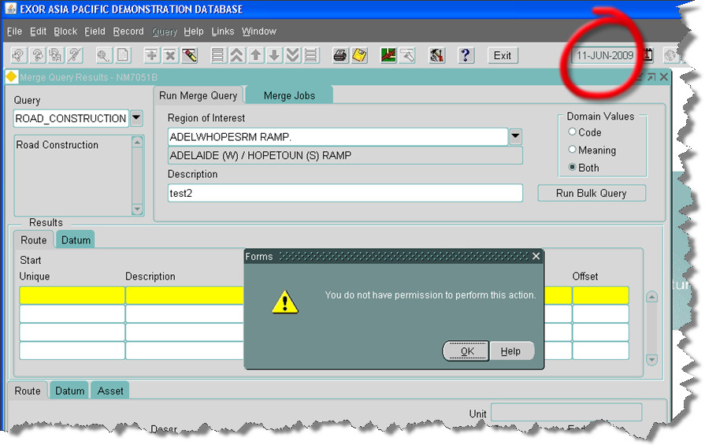

This issue was caused by a failure of the installation procedures of past versions. The installation procedure should create a context through execution of the file <exor_base>\nm3\admin\ctx\nm_sql_context.sql
and although the file was included in the release, its execution was seen to be missing. Corrective action at version 4.0.5.4 is available as fix 35. Release 4.1.0.1 will create the context. Administrators of systems at 4.1.0.0 may wish to execute the file or install version 4.1.0.1.

- Task 0108687 – Primary Key Violation on creation of Asset
Primary key violation on creation of an asset was seen to be due to an extraneous trigger on the view NM_INV_ITEMS. The trigger had originally been built to cast table differences which have now been absorbed into the product. It is now obsolete, performing nothing other than an insert into the base table. Unfortunately, on systems that include Traffic Manager a similar trigger is created to perform validation of traffic sections and count-sites. This trigger also performs inserts into the base table resulting in a primary key violation. The upgrade script of 4.1.0.1 includes the statement to drop the trigger NM_INV_ITEMS_INSTEAD_IU.

- Task 0108681 - Displaying Partial Group Membership
Partial road group indicators were not displayed correctly in Spatial Manager as illustrated below.
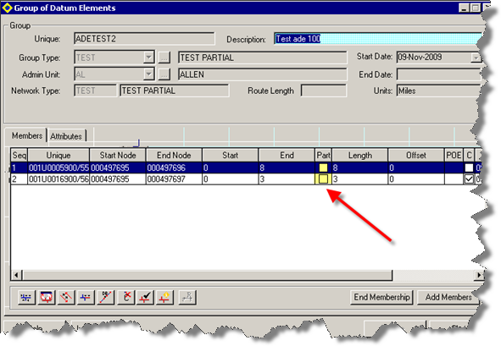
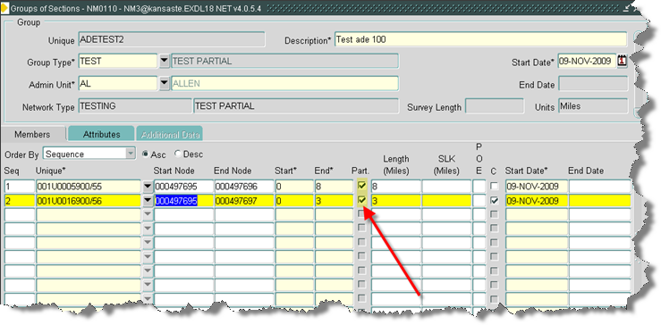

- Task 0108660 Hierarchical Assets
When assets are set up with parent/child/grandchild AT relationships ' adding a second child asset causes error:
NET-0106 ' Cannot locate asset records which are in a child AT relationship.’

This relates to three separate ecdm logs, namely 722948, 720091, 697651.

Code has been changed to allow more than one non-exclusive child assets (with exclusive Parent) with mandatory AT relationship.

- ECDM Log 722941 - Derived asset TSTR fails
Derived asset failure with resultant error message - ORA-00904: "Q"."BEGIN_MP": invalid identifier: nm3eng_dynseg_util.populate_tmp_table(p_mrg_job_id=5683, p_inv_type=TSTR).

- ECDM Log 723304 - Unable to create spatial element
Error in Spatial Manager when attempting to create a new network element whilst snapping to an orphaned node.

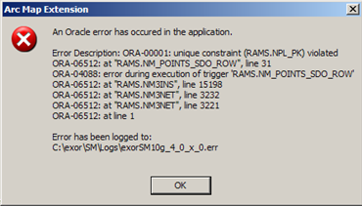

The solution is included in build 6680 or later.
- ECDM Log 722923 - GOS and splitting element
Network element modules such as NM0200, NM0110 and NM0105 are called after the conclusion of the split, merge replace and other similar modules. The called form is called after server changes are posted but not committed. The resultant called form should indicate on exit/query that the changes are not committed and allow the user to save or cancel the changes. Also, the called modules should detect that server changes are outstanding and allow the user to force a commit through the keys or toolbar.

- ECDM Log 723234 – Negative Route Measures
The form nm0122 form has been corrected to allow negative route offsets. Negative values are handled just as positive; messages will be displayed should route offsets fail to translate to a datum reference. Other modules may have similar problems and a review is being conducted. This error also relates network extent creation in SM which is a current problem but is being considered for a future release.

- ECDM Log 723017 - MQ returns invalid dates for 1950 and prior
The merge query results module displayed attribute data in an incorrect format and could convert 2-digit years incorrectly.

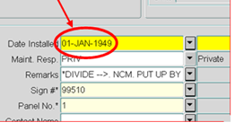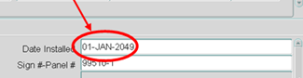

- ECDM Log 723001 - Merge of Datums with Partial Groups
Merging two datums could result in multiple location records to model a contiguous network group member. This fix is also available as 4.0.2.2 Fix 8. This corruption is caused in rare circumstances with a specific configuration of the merge with specific cardinality and order/flip settings. The resultant two members for the same datum results in a unique key violation failure when using the partial road group in the assets on a route module (NM0560).

- Task 0108592 – Merge Query Issue String buffer too small.
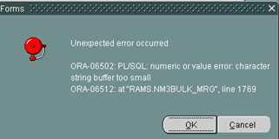

This issue is also fixed inside 4.0.5.4 Fix 36. It relates to ecdm logs 723109 and 722590.

- Task 0108567 – Network groupings
As explained in previous release notes, the integrity of the database could be compromised through invalid data entry in the network groupings modules. This release includes an improved version of NM0004 Group Types module which will perform integrity checks on the group types and their components.

- Task 0108565 – Locator Unpin Problem
A test had identified that when you unpin Locator and drag the left hand edge of the map to expand it, it will expand, but re-centring it results in the map disappearing off the right hand edge of the screen.

- ECDM Log – 720290 – Admin Unit Security and Date Logic
This fix is also available as 4.0.5.4 Fix 29. Although the ecdm log relates to measures on routes, which related to customer data problems, the log also identifies the problem that when locating an asset at a past effective date, the admin unit security would fail to find details of recently created admin units on the same datum.

- Task 0108559 – Highlight Colour in Spatial Manager
Functionality has been added to enable the user to set the selection highlight colour in Spatial Manager.

- Task 0108558 – Redundant layer Creation Buttons
Forms to handle group types and asset types (NM0004 and NM0410) have had redundant buttons removed. The buttons were used as an old method of creating spatial layers.

- ECDM Log 723068 – Locator Map measure tool failure
Also available as nm_4054_fix27, this fix allows the user to measure the length and area of lines drawn in locator on systems that are configured with a spatial co-ordinate system in units other than metres. The current display is returned in metres and the change to display the distance in the original map units will be considered in a future release.

- ECDM Log 722085 - Error creating a defect on asset
The menu tool to create defects at the centroid of a complex, compound polygon was failing as a result of the server code making a corruption to the memory-resident geometry prior to the call to evaluate the centroid. This is also available as 4.0.5.4 Fix 27. The corruption only occurred when using some multi-part polygons and had no impact other than a failure to create the defect.

- Task 0108516 – GRI0200 and PL/SQL numeric or value error
Changes to database fields in recent years had not been correctly followed through to generic core modules such as GRI0200. This module could fail with a PL/SQL numeric or value error depending on the size of data fields.

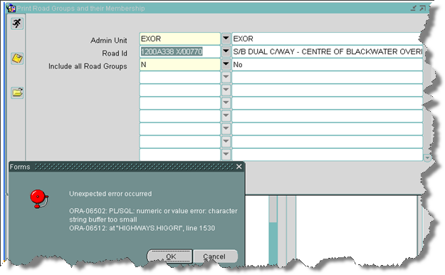

The module is required to work on a huge variety of data fields and now truncates descriptive text where appropriate.

- ECDM Log 714261 - Error modifying colours in STP4400
The inability to set the colours of layers in the STP4400 module was due to the inability to call the colour-palette module HIG1811. The 4.1.0.1 release contains an upgrade script to create the module metadata to correct this problem. By creation of the HIG_MODULE and HIG_MODULE_ROLE record. The HIG_USER role is assigned to this module. If your site does not support the use of HIG_USER role contact support.

An error displayed as ""FRM-41391 Cannot find visual attribute: invalid ID" can be resolved by setting the Visual Attribute in Asset Domain screen (NM0301)"

- ECDM Log 723431 – Error in snapping Defects to Road Network in Locator
The customer complained that Locator could not successfully snap a defect to the network. This particular problem if often due to faulty metadata, usually in the label column of the themes table. This was found to be the case and the data was repaired. However, the problem persisted and was seen to be in the nm3sdo.get_objects_in_buffer function and would result in cases where locator sub-select was not in use, where the theme-table and theme feature table were different and where the nth_feature_fk_column was null.
This is also included in 4.1.0.0 Fix 3.

- Task 0108755 – Off-network Asset Attributes in SM
In cases where an off-network asset has been registered with no spatial history, the theme is configured such that the opening of the attributes form in Spatial Manager could fail with an ORA-00904 error as shown below.
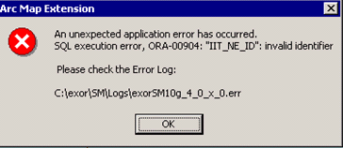

As a workaround it is recommended that the theme be registered with history such that a spatial, date-tracked join view is registered. The extraction of the ordered set of attributes into the form will be successful.

It is proposed that the join view is constructed irrespective of whether the spatial data should be date tracked in a later release.

- ECDM Log 723610 - Display of USRN no in Datum Elements
Spatial Manager could display the USRN number in a scientific notation if the number was large.

- ECDM Log 722924 – Resize Route Not Working
The resize route function has been disabled on some categories of route types. Route types that are deemed to be divided should not be resized in the way in which this code operates.

